# Hand On Lab 2 : Installing Docker CE on Ubuntu Server 18.04

**Duration: 30 Minutes**

**Objectives:**

**To learn installation of docker & docker-compose on Ubuntu box.**

**Prerequisites:**

1. Azure Subscription
2. Internet Connection
3. SSH Client ( PuTTY or Ubuntu Bash or Git Bash for Windows client)

NOTE : MacOS and Linux have built in ssh client.

1. Web Browser (Any)

**Steps :**

1. **Create Azure VM for Ubuntu Server 18.04 LTS**
2. Login into your azure portal (<https://portal.azure.com> )
3. Click on “Create Resource” to start creating new windows VM.  
   Click on “Ubuntu Server 18.04”

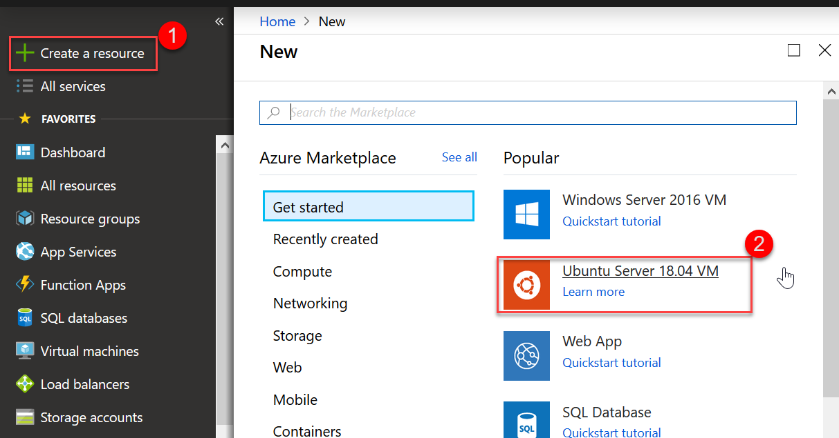

1. Create new / Use existing resource group, enter name of VM as “DockerVM2” and then scroll down for more settings.

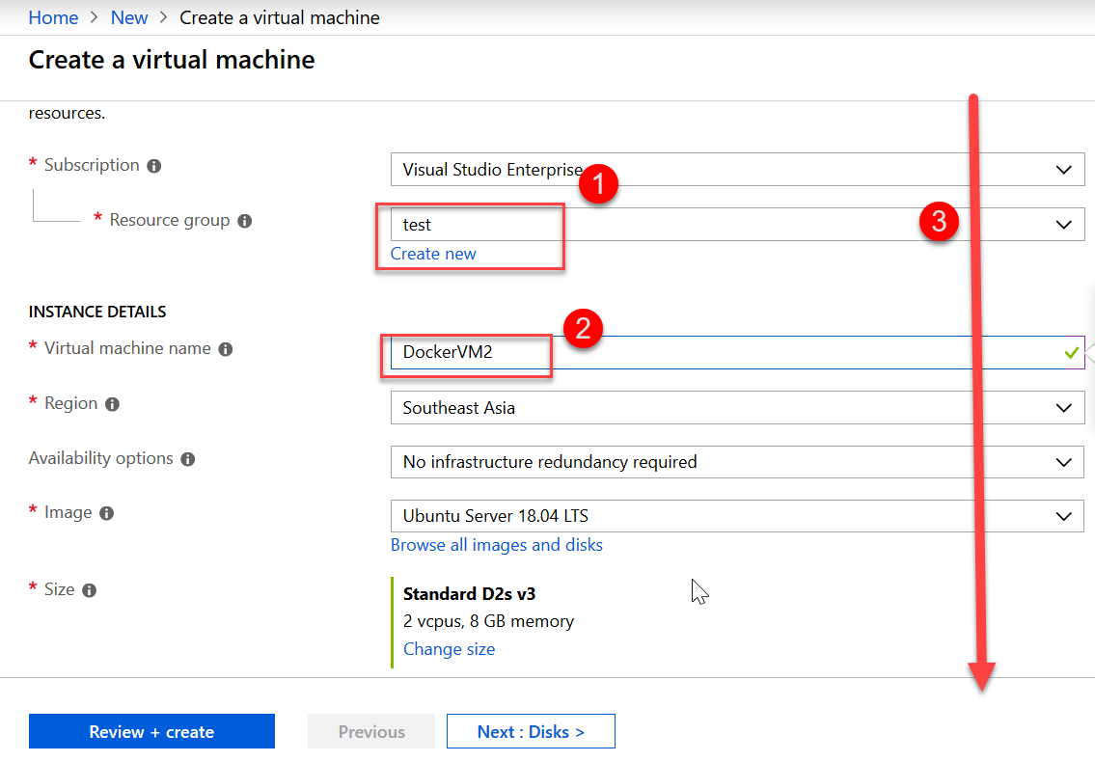

1. Choose “Password” for authentication and then enter user/password. Also need to open port 22 for SSH access.

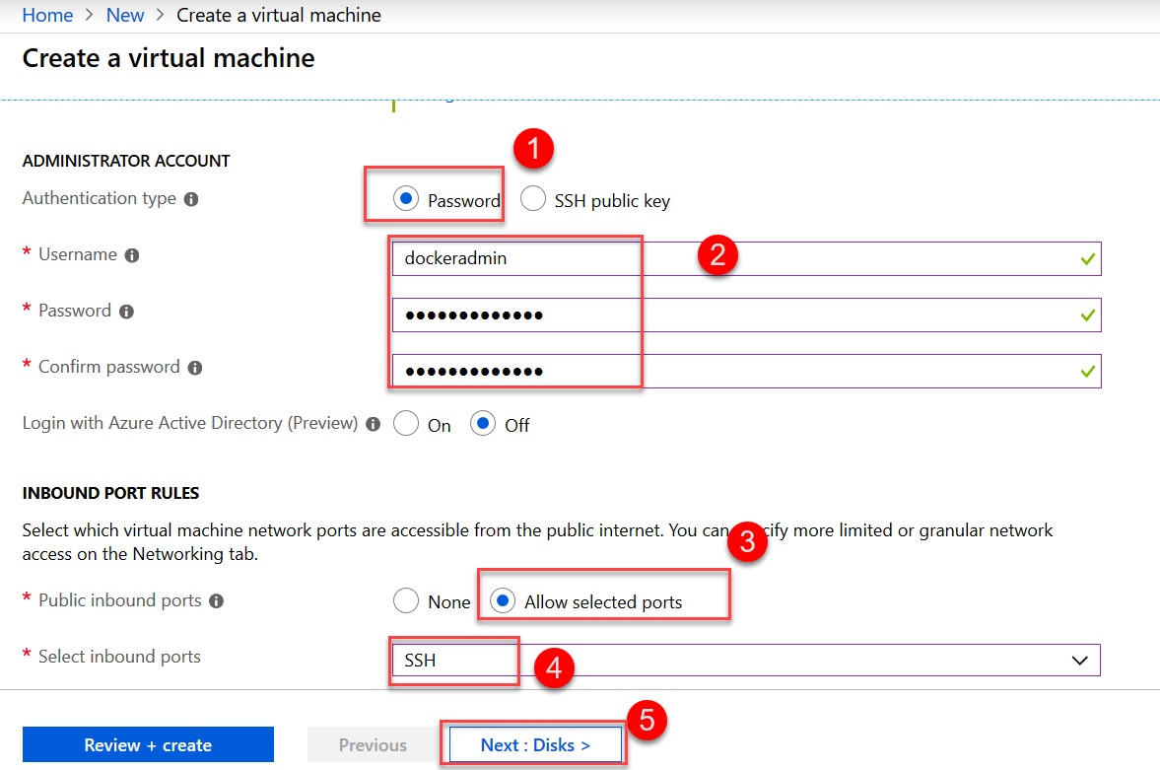

Click on “Next: Disk >” for disk configuration.

1. Click “Next: Networking >” to accept the defaults and skip disk management.
2. Click “Next: Management >” to accept the defaults and skip networking.
3. Now, Turn Off boot diagnostic and click on “Review + Create”

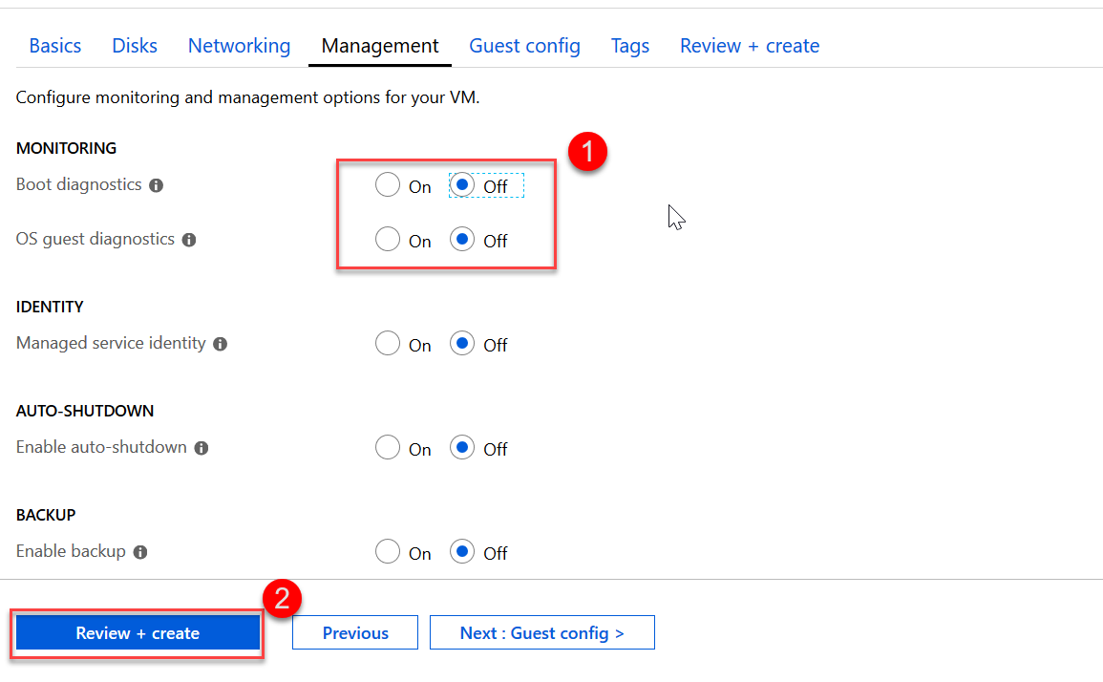

1. Click “Create” on final validation page to start provisioning the VM.

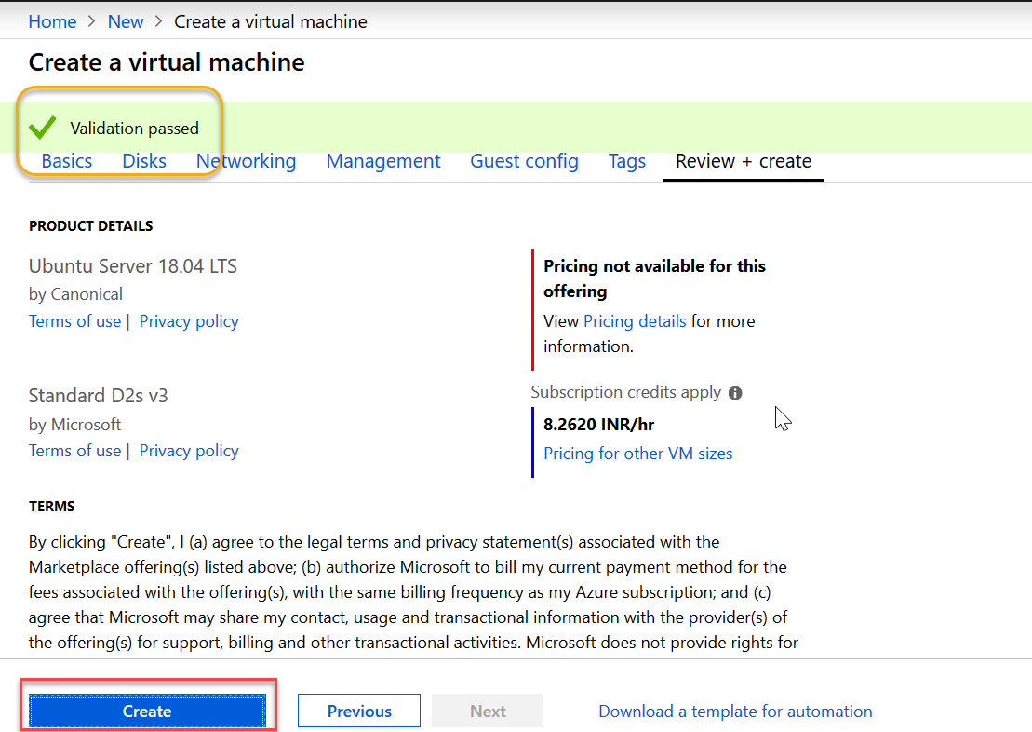

1. Click on “Go to resource” once deployment finishes.
2. Click on connect to retrieve ssh connection parameters

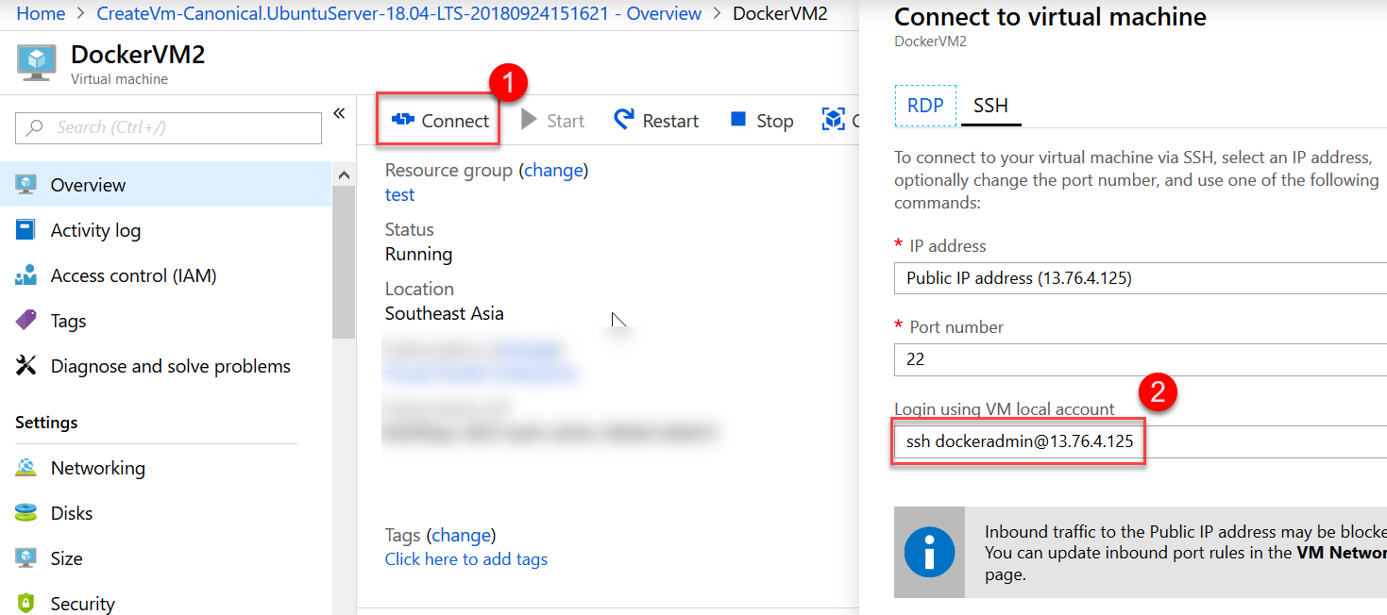

1. **Installation of Docker CE & docker-compose**
2. Open Ubuntu bash ( on Windows 10 pro) or Git Bash ( on all windows)
3. Enter ssh connection string copied from step 10.

Then enter “yes” when prompted

Enter password when prompted for password

NOTE : Linux terminal should never echo password or any masked character (*).

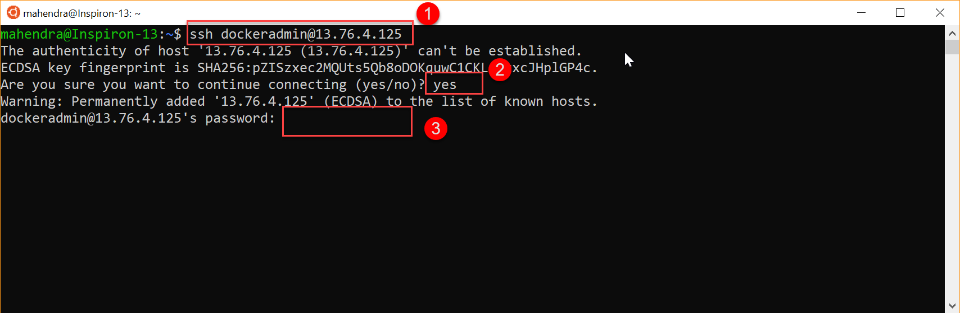

1. Try running “docker info” command to check if docker is pre-installed. You should get following message:

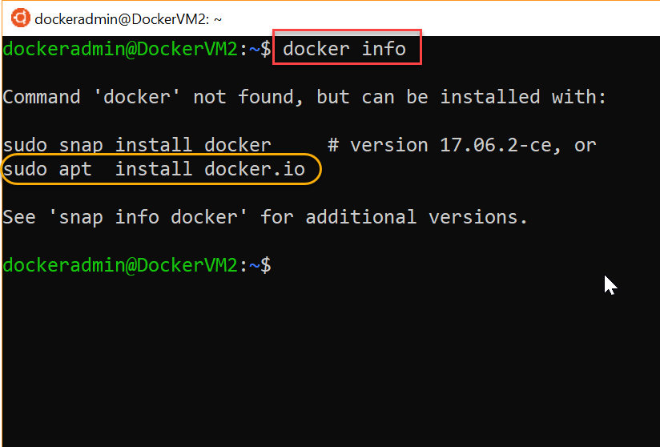

1. As the message clearly suggests, use apt command to install docker.

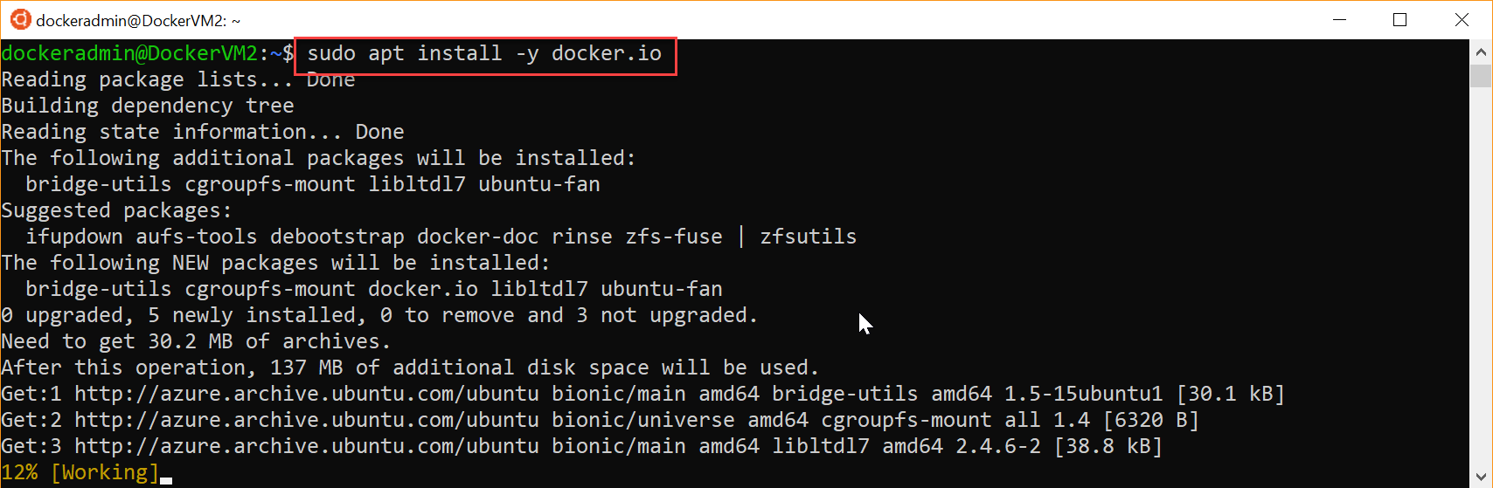

NOTE : the additional “-y” is to supress prompt which confirms installation.

1. Use command to enable current user to access docker cli without “sudo”

$ sudo usermod -aG docker $USER

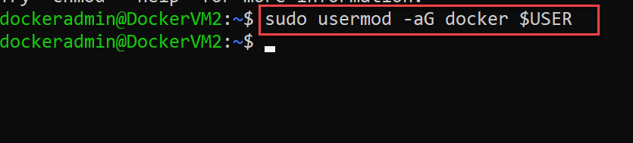

1. Now, logout and login back [Linux Admins : reload current bash session]

Run command “exit” and then “ssh …” to reconnect

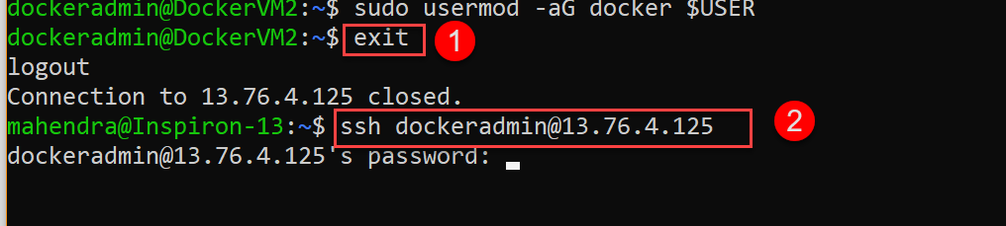

1. Test docker installation with command “docker info”

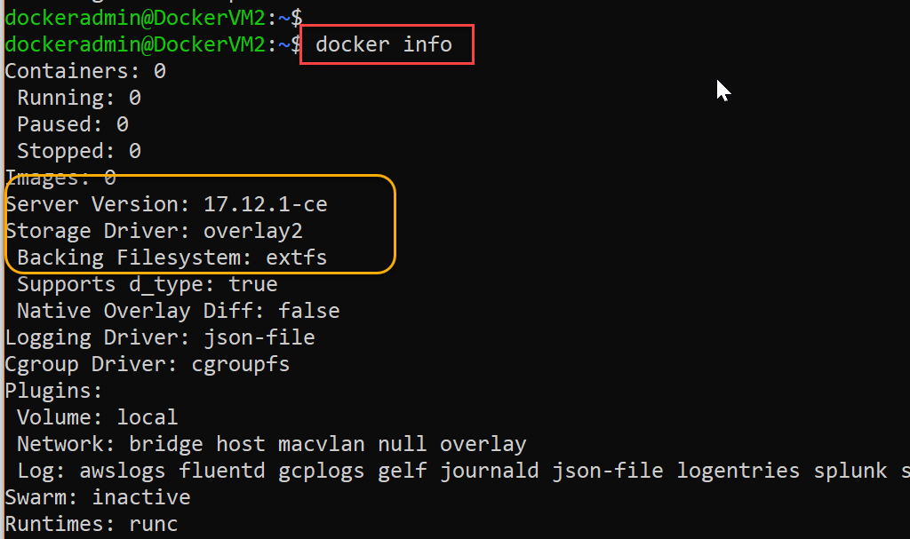

1. Install “docker-compose” using following command:

$ sudo apt install -y docker-compose

1. Few additional ports are required for next few HOLs, use portal to open them

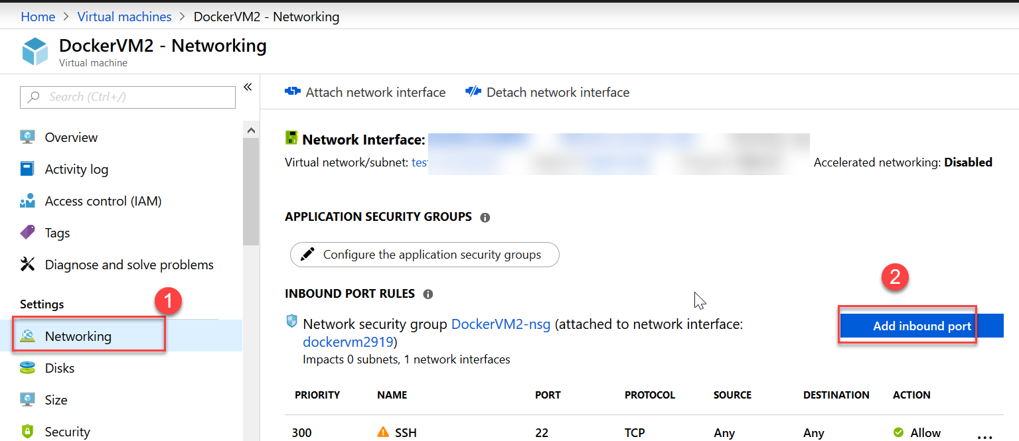

1. In “Source port ranges” type “*” and in target port ranges type “8000” then click “Apply”

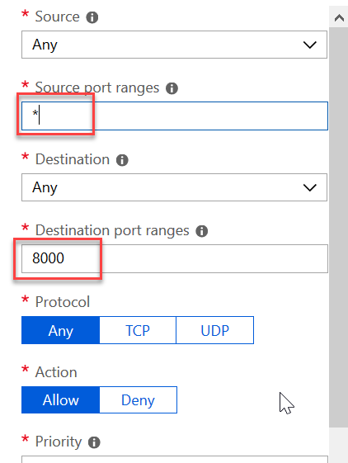

1. Stop the VM from Azure portal

